AI GIFT RECOMMENDATION & PRIORITY SYSTEM
Multi-Step Prompt Workflow for Personalized Exam Preparation

STUDENT | S DEEPADHARSHINI
REGISTER NO. | 9923005245
ASSESSMENT | Mini Assessment — Prompt Workflow Design

| Concept
Purpose:AI Gift Recommendation & Priority System analyzes a user's gift request and converts the provided recipient details, occasion, interests, budget and deadline into suitable personalized gift recommendations.
Problem: Choosing an appropriate gift can be difficult when users have different preferences, budgets and time constraints. A simple AI prompt may generate generic suggestions without properly considering all requirements. A structured multi-step prompt workflow solves this problem by first extracting the important gift details, then reasoning about urgency and suitable gifts, and finally producing a structured recommendation.

| Objective
The objective of this workflow is to design a sequential AI prompt system that understands a user's gift requirements, determines the urgency of the request, recommends suitable gifts based on the extracted information, and presents the final result in a structured JSON format.
Each stage uses the output generated by the previous stage, creating a connected and reusable prompt workflow.

| Workflow Overview
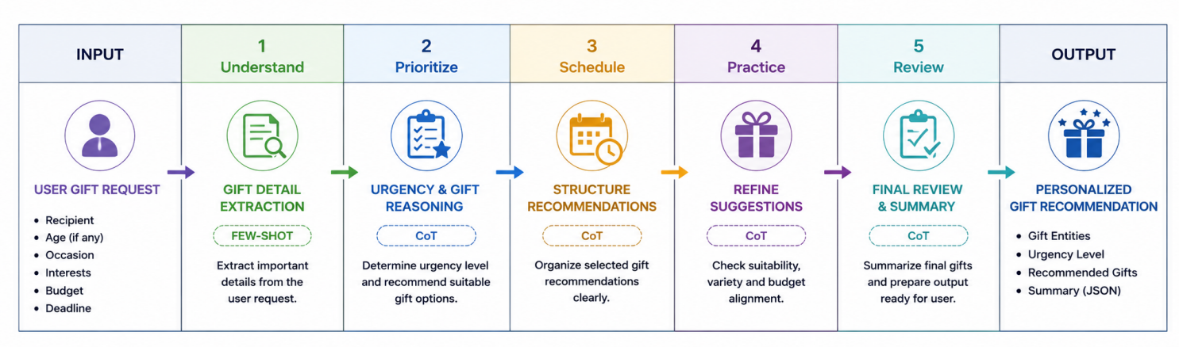

| Workflow Steps
The module specifically requires the three techniques to be used in these respective stages.

1. Gift Detail Extraction
Extract the important information from the user's gift request, including recipient, age, occasion, interests, budget and deadline.
Technique: Few-shot Prompting
Output: Gift-related entities

2. Urgency & Gift Recommendation Reasoning
Use the extracted information from Step 1 to determine whether the gift request is low, medium or high urgency and select suitable gift options.
Technique: Chain-of-Thought Reasoning
Output: Urgency + Gift Recommendations

3. Final Gift Recommendation
Combine the extracted entities and reasoning result into a structured and machine-readable final response.
Technique: JSON Mode
Output: Valid JSON recommendation.

| Prompt Workflow

Step 1 Gift Detail Extraction
Technique: Few-shot Prompting
The AI extracts important gift-request details such as Recipient, Age, Occasion, Interests, Budget, and Deadline. Examples are provided to show the expected format.
Prompt:
You are an AI Gift Assistant. Extract the following from the user's gift request: Recipient, Age, Occasion, Interests, Budget, and Deadline. Do not recommend gifts.
Example: “I need a birthday gift for my brother. He loves cricket. My budget is ₹1000.”
Output: Recipient: Brother, Age: Not specified, Occasion: Birthday, Interests: Cricket, Budget: ₹1000, Deadline: Not specified.
Now extract the details from:
{{USER_INPUT}}
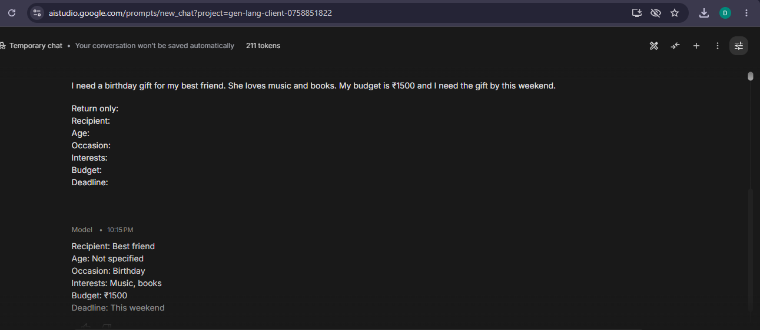

Step 2 Urgency & Gift Recommendation
Technique: Chain-of-Thought (CoT)
The AI uses the actual Step 1 output to determine the urgency level and recommend suitable gifts.
Prompt:
You are an AI Gift Recommendation Advisor. Using the Step 1 output, determine the urgency as Low, Medium, or High. Consider the deadline, occasion, interests, and budget. Then recommend three suitable gifts.
Step 1 Output: {{STEP_1_OUTPUT}}
Return:
Urgency:
Reason:
Gift 1:
Gift 2:
Gift 3:

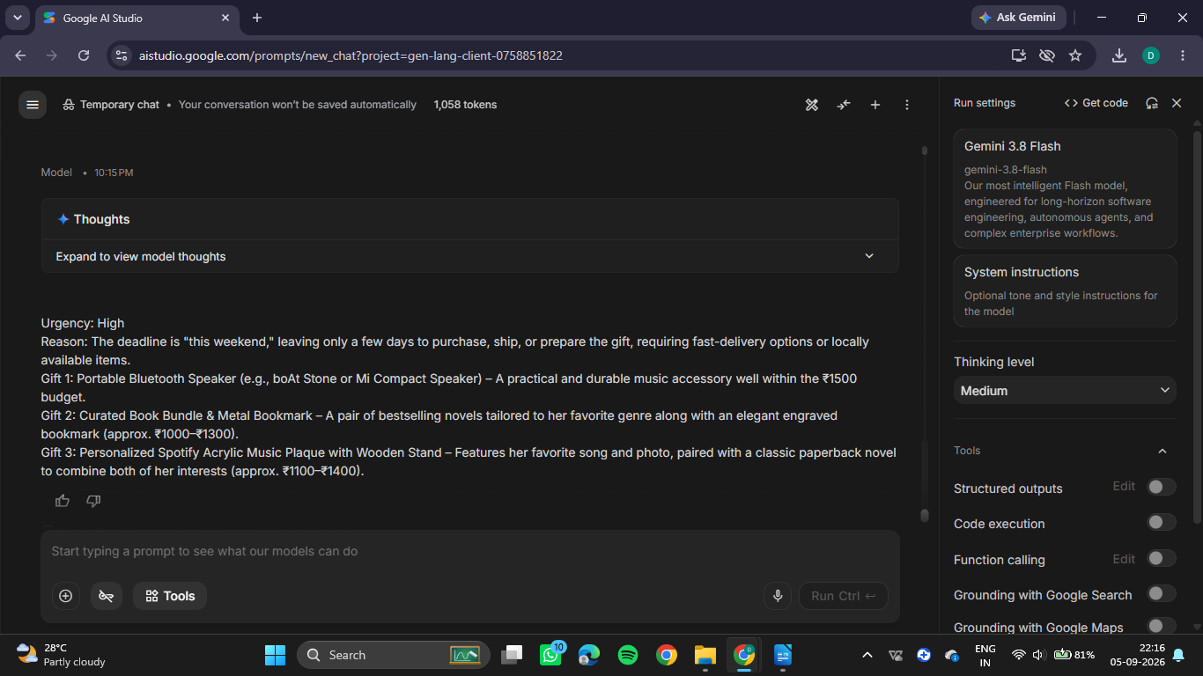

Step 3 Final Gift Recommendation
Technique: JSON Mode
The outputs from Steps 1 and 2 are converted into a valid, structured JSON format with exactly three keys. The module specifically requires entities, urgency, and summary, with the final output being parseable JSON.
Prompt:
Use the outputs from Step 1 and Step 2. Return only valid JSON with exactly these keys:
{"entities": [], "urgency": "", "summary": ""}
Step 1 Output: {{STEP_1_OUTPUT}}
Step 2 Output: {{STEP_2_OUTPUT}}
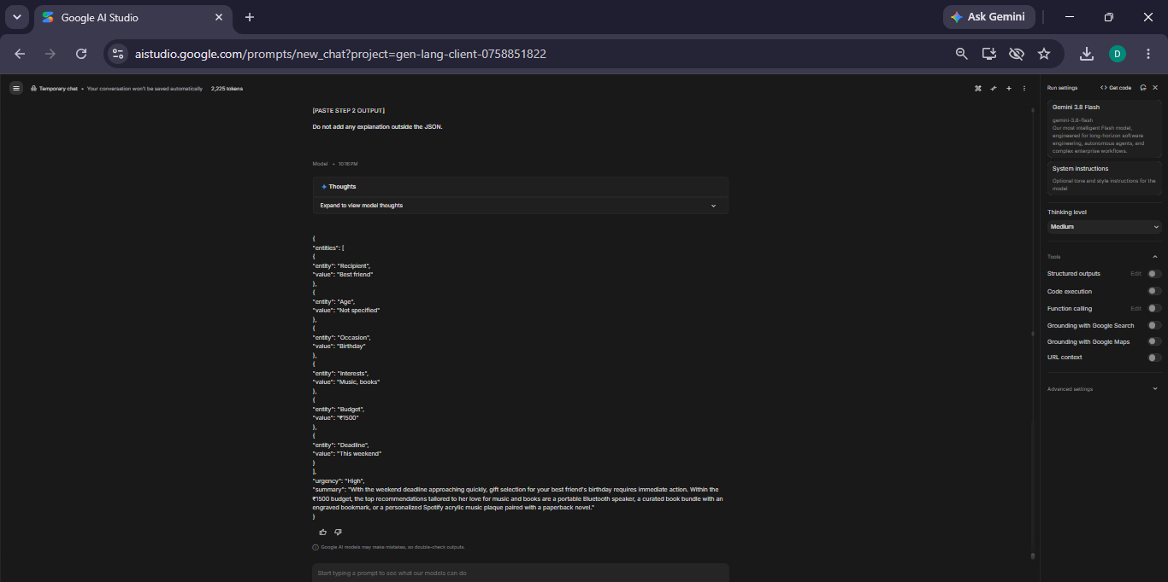

06 | Prompt Chaining
Step 1 extracts the gift-related entities from the user's request.
Step 2 uses the actual Step 1 output to determine urgency and recommend suitable gifts.
Step 3 uses both previous outputs to generate the final structured JSON result.

STAGE | INPUT / CONTEXT | OUTPUT
1 | User Gift Request | Gift Entities
2 | Step 1 Extracted Entities | Urgency + Gift Recommendations
3 | Step 1 + Step 2 Outputs | Final JSON

07 | Demonstration Input
Input:
“I need a birthday gift for my best friend. She loves music and books. My budget is ₹1500 and I need the gift by this weekend.”
Step 1 – Extract Details:
Recipient: Best friend | Occasion: Birthday | Interests: Music, books | Budget: ₹1500 | Deadline: This weekend
Step 2 – Reason & Recommend:
Urgency: High
Gifts: Portable Bluetooth Speaker, Curated Book Bundle & Metal Bookmark, Personalized Spotify Acrylic Music Plaque with Novel.
Step 3 – Final Output:
The system generated a structured JSON containing the extracted entities, High urgency, and a summary of the recommended gifts.
Result:
The workflow successfully transformed the user's gift request into a personalized and structured recommendation.

08 | Key Benefits
- Personalized Recommendations – Suggests gifts based on interests and budget.
- Time-Saving – Quickly identifies suitable gift options.
- Priority-Based – Determines urgency from the deadline.
- Structured Output – Provides clear and organized JSON results.
- Reliable Workflow – Uses prompt chaining for consistent results.
09| Conclusion
The AI Gift Recommendation System successfully demonstrates a multi-step prompt workflow using Few-Shot Prompting, CoT-based reasoning, and JSON Mode. The workflow extracts user requirements, determines urgency, recommends suitable gifts, and produces a structured final output. This shows how prompt chaining can make AI responses more personalized, organized, and reliable.

